Project Design Phase
Problem – Solution Fit Template

Date | 15 February 2025
Team ID | LTVIP2026TMIDS55906
Project Name | Strategic product placement analysis: unveiling sales impact with tableau visualization
Maximum Marks | 2 Marks

Problem – Solution Fit :
Retail businesses often struggle to understand how product placement inside the store impacts sales, because sales reports are scattered, layout data is not visual, and insights are not clear.
This project provides a Tableau-based visualization system that combines sales data with store layout to reveal which product placements drive the highest sales, enabling data-driven decisions to optimize store performance.
Purpose:
- Identify the store zones and shelf positions that increase sales.
- Visualize sales and placement data through interactive Tableau dashboards.
- Compare product performance before and after placement changes.
- Enable data-driven decision-making for retail managers and analysts.
Template:
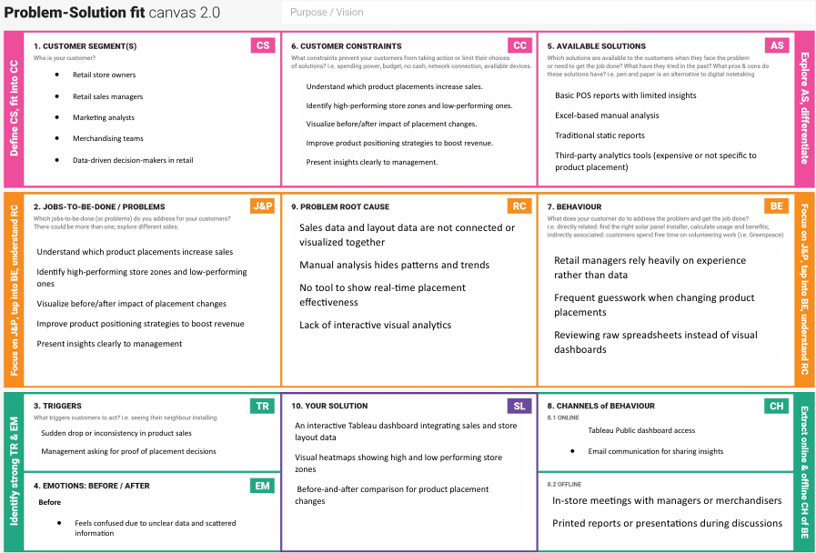
References:
- https://www.ideahackers.network/problem-solution-fit-canvas/
- https://medium.com/@epicantus/problem-solution-fit-canvas-aa3dd59cb4fe

